Contents
Outlines 2
Data cleaning 3
Missing data: None, NaN, 3
Handling Missing Data 3
Duplicate data 3
other 3
Data Wrangling 4
Data Visualization: making data understandable 5
Pandas 6
Matplotlib 6
Basic Definitions 7
Types of Measurement 7
Choosing an Appropriate Visualization (for exploration) 8
Data Visualisation Catalogue 8
Data Summarization 9
Normalization 9
Linear Regression 10
The Regression Line 12
The p-value 13
Simpler Model 13
Criteria 14
Train-test split for prediction 14

Outlines

- Cleaning:

- Wrangling:

Common Data Problems:

Example:
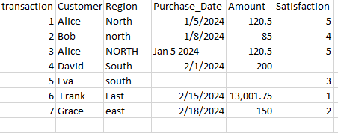

Data cleaning

Missing data:

Duplicate data

Other

Demonstrate

Data Wrangling

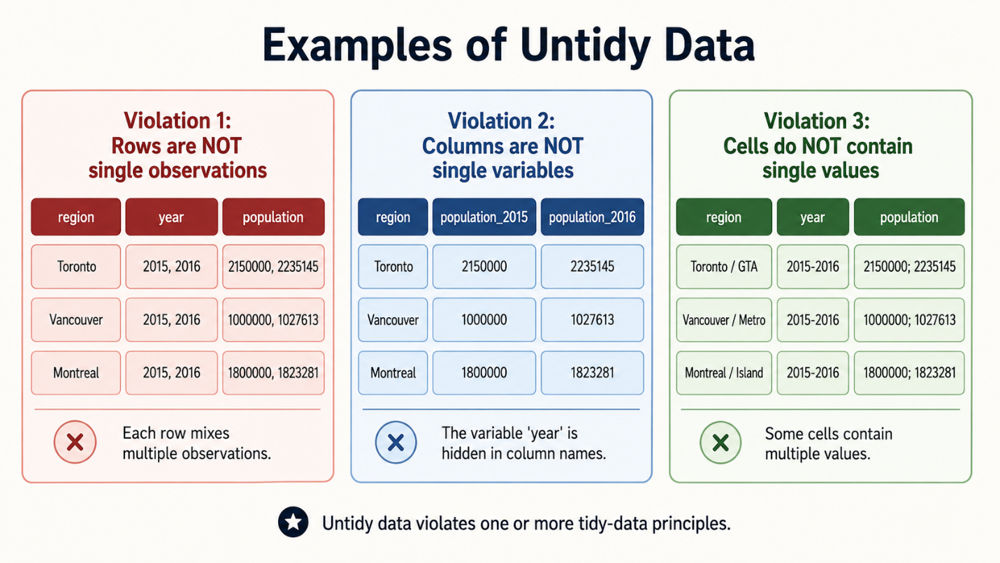

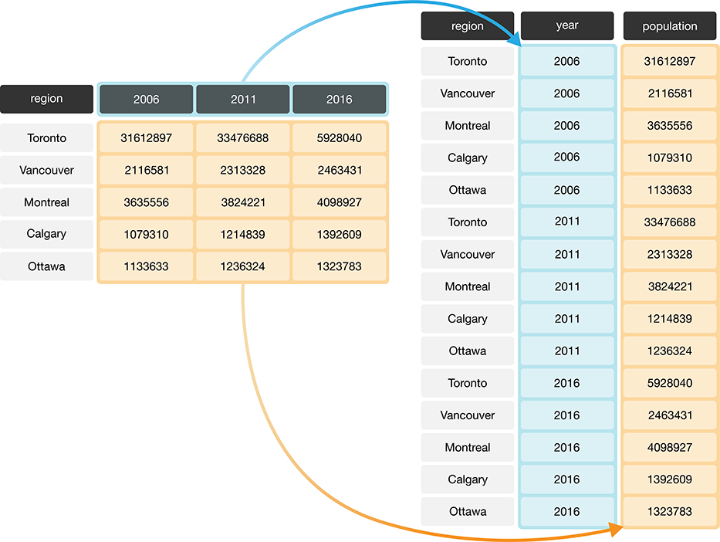

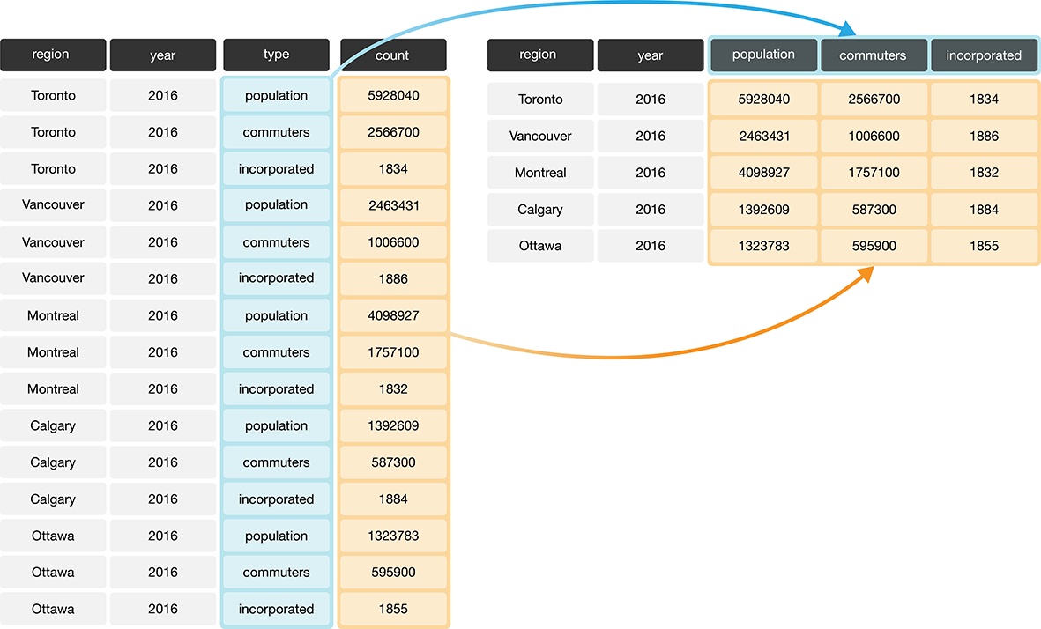

Filtering
Selecting columns
Sorting
Grouping
Aggregating
Merging
Reshaping

Data Visualization: making data understandable
- Visualization
Question | Recommended Chart
Summary
Compare groups
Change over time
Distribution
Relationship

Pandas

Matplotlib

seaborne

demonstrate

Basic Definitions
- Data set
- Rows -
- Columns
item_id | asin | brand | rating | totalReviews | price | originalPrice
i0001 | B0000SX2UC | NaN | 3.0 | 14 | 0.0 | 0.0
i0002 | B0009N5L7K | Motorola | 3.0 | 7 | 49.95 | 0.0
i0003 | B000SKTZ0S | Motorola | 2.7 | 22 | 99.99 | 0.0
i0004 | B001AO4OUC | Motorola | 3.3 | 21 | 0.0 | 0.0

Types of Measurement
- Nominal:
- Ordinal:
- Interval:
- Ratio:

Choosing an Appropriate Visualization (for exploration)
Data Type | Visualization
One continuous variable | Histogram, Empirical CDF
One categorical variable | Barplot
One continuous and one categorical variable | Box plot
Two continuous variables | Scatter plot
Three continuous variables | 3-D scatter plot

Data Visualisation Catalogue https://datavizcatalogue.com/

Data Summarization
Centrality dispersion

Normalization

Linear Regression

Question | Input Variable | Output Variable
Does advertising spending affect sales? | Advertising budget | Sales
Does study time affect test score? | Hours studied | Test score
Does home size affect house price? | Square footage | House price
Does experience affect salary? | Years of experience | Salary

Example
Suppose we have data about study hours and exam scores.
 | Hours_Studied | Exam_Score
0 | 1 | 55
1 | 2 | 60
2 | 3 | 65
3 | 4 | 70
4 | 5 | 75
5 | 6 | 80
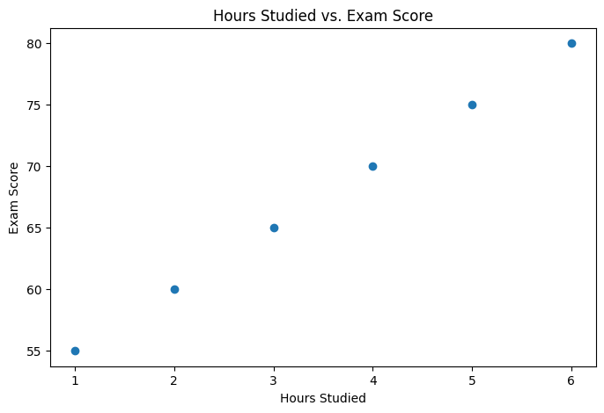

The Regression Line
Simple linear regression fits a straight line through the data.
The equation is:
$$y=mx+b$$In statistics, we often write it as:
$$y=β_{0}+β_{1}x$$
For the study example:
$$\text{Exam Score}=β_{0}+β_{1}(\text{Hours Studied})$$
Lecture explanation:

Then:
Part | Meaning
50
5

The p-value

Simpler Model

For prediction:

Criteria

Train-test split for prediction

Stepwise

